Center Rock Inc. delivers………..
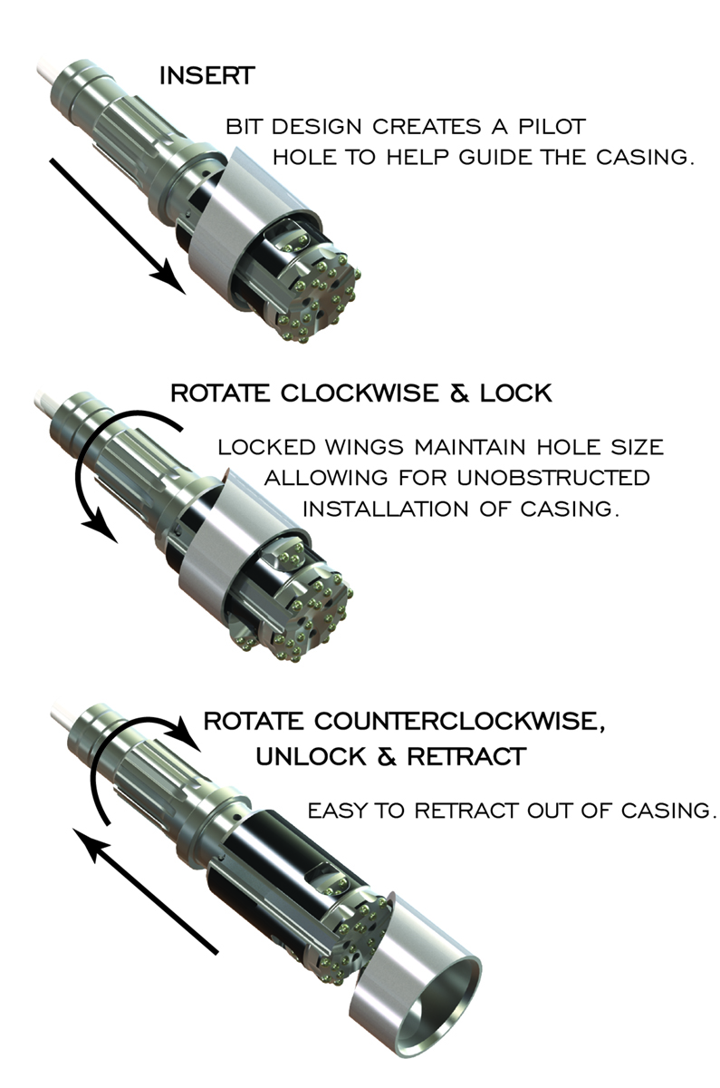
Center Rock Inc. designs, engineers, manufactures, and distributes a complete line of air drilling tools and products. At our two state-of-the-art manufacturing facilities in Berlin, Pennsylvania, we manufacture and stock products that are used by foundation and construction companies, leading oil and gas drillers, water well drillers, and quarry & mining contractors across the globe. And, when our customers demanded products specifically for geotechnical drilling and exploration drilling, we delivered.
Geotechnical Drilling Solution……….
Building upon the need for a better solution, Center Rock designed its ROTO LOC overburden drilling system to work flawlessly in the most demanding casing advancement situations. Geotechnical drilling contractors have long struggled with challenging drilling conditions caused by pinnacle limestone and karst formations. In response to this challenge, Center Rock has developed ROTO LOC, the ultimate in under reamer systems. Unlike competitive systems, ROTO LOC does not require casing J-teeth or expensive sacrificial rings. The savings from this feature alone could easily cover the acquisition cost of the system, which makes using ROTO LOC a no-brainer.
ROTO LOC systems are made up of a shank and a pilot. The shank rotates into the pilot causing the wings to extend and lock into place. The wings are positively locked in place which ensures that the hole size will be maintained allowing for unobstructed installation of casing. The pilot nose leads the wings with enough length that in karst formations it gets a toe hold before the wings make contact and drills a straight hole.
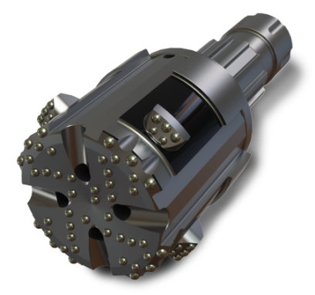
David Friday, Superintendent for Hayward Baker says; “We have been using the 9-5/8” ROTO LOC system very extensively for the last 3-1/2 years. ROTO LOC has outperformed other systems in extreme karst conditions, wet abrasive sands, and very sticky clays….and has a super penetration rate in hard rock.”
ROTO LOC is available in a variety of sizes from 5.5 in. (140 mm) to24 in. (610 mm) with larger sizes upon request. These systems are specifically tailored to the needs of the market and as you can see from the above testimonial, once you try ROTO LOC, you will be a believer.
Exploration Drilling Solution…………
Also new to the Center Rock portfolio are Rock Xtreme center recovery, reverse circulation hammers & bits which deliver undisputable performance and profitability in the most challenging exploration drilling operating conditions. These tools are specifically designed for the exploration market and have proven to have faster penetration rates than competitive offerings.
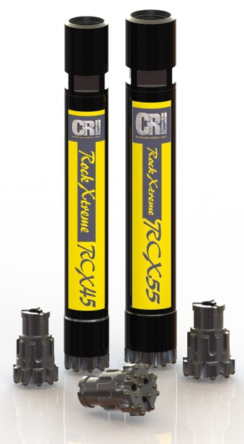
The RCX line of tools has (2) current offerings; the RCX55 which covers hole sizes from a minimum of 5.4 in. (137 mm) to a maximum of 6.0 in. (152 mm), and the RCX45 which is a new offering for 2016 and covers hole sizes from a minimum of 4.75 in. (121 mm) to a maximum of 5.5 in. (140mm). These tools, pictured, have taken the industry by storm. Typically, center recovery hammers are slower than their conventional hammer counterparts. Center Rock was not willing to sacrifice performance in their line of reverse circulation tools, so, the RCX models closely mirror the productivity of the RX line of conventional hammers.
RCX hammers utilize the proprietary Center Rock steel valve cycle to develop its’ high performance coupled with a weight-matched piston and bit for efficient energy transfer. Also noteworthy is the fact that the tool utilizes a high frequency cycle which ensures solid performance in hard formations while helping enhance performance in softer formations, including clays. The high frequency also lessens recoil vibration which reduces downtime for rotary head and drill rig maintenance.
RCX reverse circulations hammers are short and lightweight which make them easier and safer to handle. The RCX product has a simple low-part construction for easier service and greater reliability. And, the collection tubes are through-hardened for long service life. Lastly, RCX bits have a relatively large shank spline cross section which resists chuck wear and shank-offs. 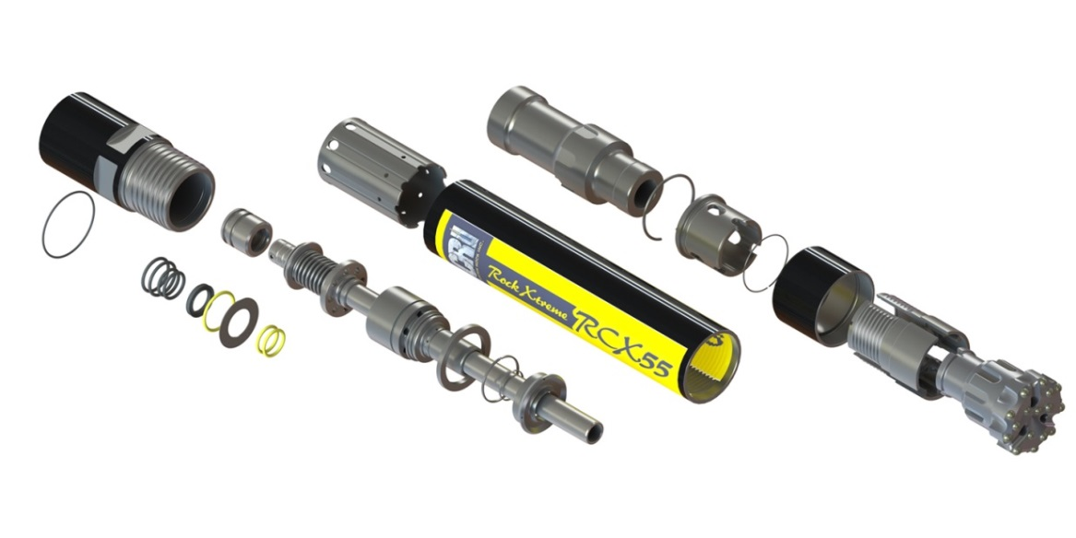
Because Center Rock Inc. is focused only on downhole drilling products, we are able to afford our customers the fastest available response time and customized solutions. The approach that Center Rock embraces every day is to help our customers solve the most difficult drilling problems utilizing creativity, drilling expertise and entrepreneurial spirit. Call or contact Center Rock today to start working with a team that can solve your drilling problems immediately by designing and manufacturing a product for you in a matter of days not months.

